MySQL Assignment

GMCA 4 – Day 1
MySQL Tasks-Shafaq Asif

QUERY 1
USE sql_store;
SELECT *
FROM customers;
Explanation: The SQL USE statement is used to select any existing database in the SQL schema, Here it’s using “sql_store” database. The SELECT * statement is selecting all the rows and columns from the table “customers”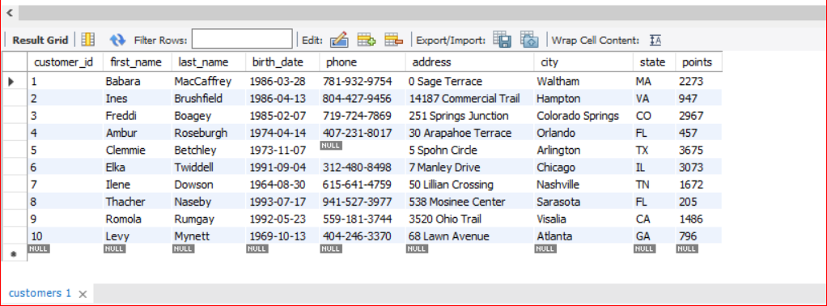

QUERY 1 Continued..
USE sql_store;
SELECT * FROM customers
WHERE customer_id=1
ORDER BY first_name;
Explanation: “WHERE”Clause is pointing to the coloumn name “ customer_id where value is=”1”. The “ORDER BY” keyword is used to sort the result-set in ascending or descending order. 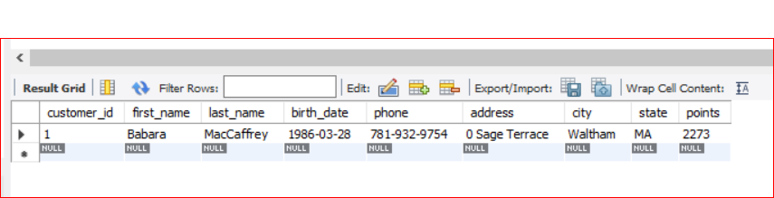

QUERY 2 SELECT
TASK 1(a)
SELECT last_name, first_name, points, points + 10
FROM CUSTOMERS;
Explanation: This stamen is selecting coloumn last_name, , first_name, points, points + 10 from CUSTOMERS table.
Explanation: the “points+10” will add 10 points to the coloumn “point” into new column named “point+10”.

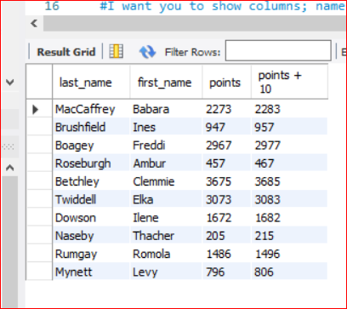
TASK1(b)
SELECT last_name, first_name, points, (points + 10) * 100 as Discount_factor
FROM customers;
Explanation: The “as” clause is used here as alias and will change the coloumn name “points+10” to new column name as “ discount_factor”

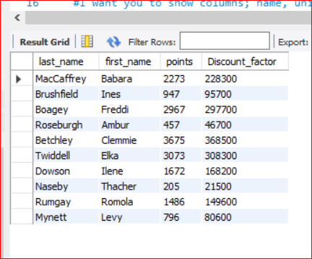
Task 2
SELECT name, unit_price, unit_price * 10/100 + unit_price as New_price
FROM products;
Explanation: This SQL query returns all the products in our database as a result set.
I want to show columns; “name”, and “unit_price”, and a new column called “new price” which is based on this expression, (unit price * 1.1 ).
The query is also increasing the product price of each by 10%.
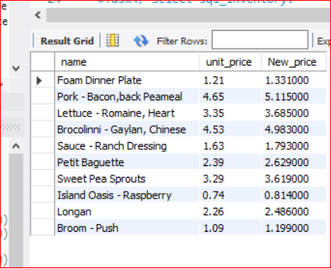
TASK3
SELECT first_name, last_name, birth_date FROM customers
WHERE birth_date > '1990-01-01';
Explanation: This query creates a new query to find all the customers with a birth date greater than '1990-01-01'.
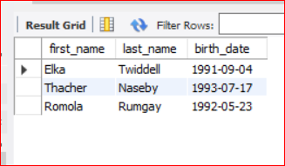

TASK4
Use sql_inventory;
SELECT quantity_in_stock FROM products;
SELECT Max(quantity_in_stock) from products;
Explanation: This query will use “sql_inventory” database , then selects “quantity_in_stock from the “products” table.
The next query finds out the name of the product with maximum amount in stock.

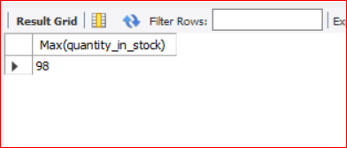

TASK5
SELECT unit_price FROM products;
SELECT MAX(unit_price) FROM products;
Explanation: By selecting “sql_inventory” database, this query finds out the name of the most expensive product.

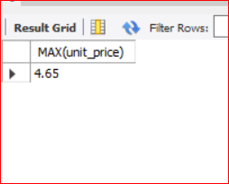

TASK6
USE sql_store;
SELECT first_name, last_name, address, birth_date FROM customers
ORDER BY birth_date;
Explanation: Selecting “sql_store” database again, this query finds out the “first_name”, “last_ name”, “address” and the “birth_date” of the oldest customer.

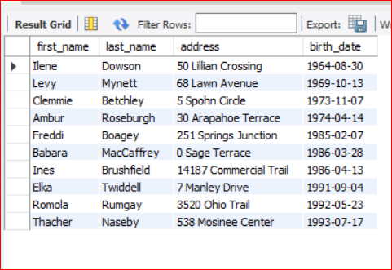

EER Diagram

